Form labels with the DisplayName and Label components

Tested Scenario: (Tested in all render modes and standalone WASM)

S No | Scenario | Test status | Comments
1 | Set the Display attribute to property | Work properly | -
2 | Set the DisplayName attribute to property | Work Properly | -
3 | Set both Display and DisplayName attribute to same property. | Work Properly | Component taken Display value over DisplayName
4 | Neither set the Display or DisplayName Attribute | Work Properly | Taken the name from property name.
5 | Clicking on label, focus passes to respected input element | Work properly | -
6 | Keyboard navigation access | Work properly | -
7 | Inspect the element and confirm the id, name and form element attribute and their values | Work properly | -
8 | Standalone Label with input element | Work Properly | -
9 | Wrapper input element with Label | Work Properly | -
10 | The same property rendered by DisplayName in a table header and by Label in the form. | Work Properly | -
11 | Nested-branch fields, including a property name that also exists on the root. | Work Properly | -
12 | Submitting invalid values and reading how fields are named in the messages. | Work Properly | -
13 | Setting an id on an input yourself and seeing what its Label does. | Partial - work | - Standalone Label – focuse does not set, rest are work as expected.  - Wrapper Label with input element – work as expected.
14 | Localized names supplied with [Display(ResourceType = typeof(MyResources), Name = "...")]. | Work properly in WASM | Not works in SSR and Server mode.
15 | A nested field and a same-named root field render different id values, each label pointing at its own input. | Work Properly | -
16 | Label with AdditionalAttributes support. | Work Properly | -
17 | Inputs rendered on the server, which means static SSR and Interactive Server, also render a name attribute so the form can post | Work properly | 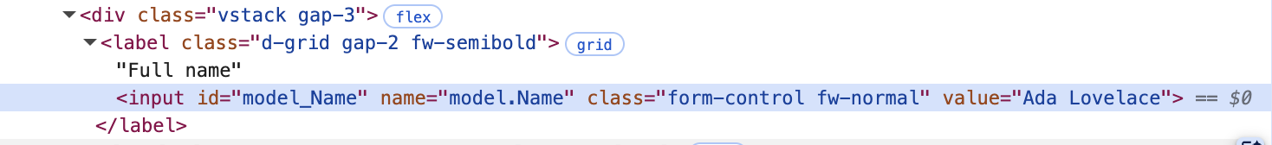

Issues found
Issue-1:
When I set validation fields for the InputNumber component with standalone Label component, the validation message shows the property name instead of the displayName attribute.
<div class="mb-3">
<Label For="@(() => product.UnitPrice)" class="form-label" />
<InputNumber @bind-Value="product.UnitPrice" id="product-unit-price" class="form-control" />
<ValidationMessage For="@(() => product.UnitPrice)" />
</div>
….
[Range(0.01, 10000)]
[System.ComponentModel.DisplayName("Unit price")]
public decimal UnitPrice { get; set; } = 49.95m;

In Auto / Server / WASM:
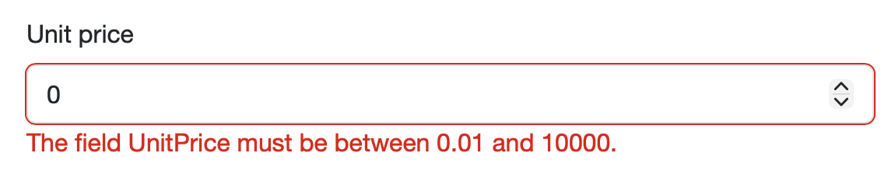
In SSR:
